**Experiment 7**

**Student Name: Ruchika Raj UID: 20BCS9285**

**Branch:** BE CSE **Section/Group:** 615-B

**Semester:** 5th

**Subject:** Web and Mobile Security Lab **Subject Code:** 20CSP_338

**Aim/Overview of the Practical:**

Implementation of Session hijacking attack on http-enabled website.

**Task to be done / Which logistics used:**

To Identify vulnerable session cookies.

**Software / Hardware Requirements:**

Burp Suite PC **Introduction:**

Session Hijacking

The Session Hijacking attack consists of the exploitation of the web session control mechanism, which is normally managed for a session token. Because http communication uses many different TCP connections, the web server needs a method to recognize every user’s connection. The most useful method depends on a token that the Web Server sends to the client browser after a successful client authentication.

The Session Hijacking attack compromises the session token by stealing or predicting a valid session token to gain unauthorized access to the Web Server.

The session token could be compromised in different ways; the most common are:

●

Predictable session token;

●

Session Sniffing;

* Client-side attacks (XSS, malicious JavaScript Codes, Trojans, etc.);

* [Man-in-the-middle attack](https://owasp.org/www-community/attacks/Man-in-the-middle_attack)
* [Man-in-the-browser attack](https://owasp.org/www-community/attacks/Man-in-the-browser_attack)

**Steps for experiment/practical/Code:**

Step-1: -Ensure that Burp is correctly [configured with your browser an](https://portswigger.net/burp/documentation/desktop/external-browser-config)d intercept is turned off in proxy Intercept tab.

Step-2: -Visit the login page of the application you are testing in your browser and Log in to the application you are testing.

For example: -You can log in using the credentials user: user.

Step-3: -Now, In the [Proxy Int](https://portswigger.net/burp/documentation/desktop/tools/proxy/getting-started)ercept tab, ensure "Intercept is on”. Refresh the page in your browser. Then request will be captured by Burp, it can be viewed in the [Proxy "I](https://portswigger.net/burp/documentation/desktop/tools/proxy/getting-started)ntercept" tab.

Step-4: -We now need to investigate and edit each individual cookie.

Right click anywhere on the request and click "Send to [Repeater".](https://portswigger.net/burp/help/repeater.html)

Go to the [Repeater ta](https://portswigger.net/burp/help/repeater.html)b. The cookies in the request can be edited easily in the "Params" tab.

Step-5: -By removing cookies from the request, we can ascertain the function of each cookie.

Cookies can be edited in the Request "Params" table.

Step-6: -The response from the server can be viewed in the "Response" panel in Repeater. The response shows that by altering the "uid" cookie we have logged in to the application as "admin".

We have used cookies to manipulate the session and access another account with elevated privileges.

**Result/Output/Writing Summary:**

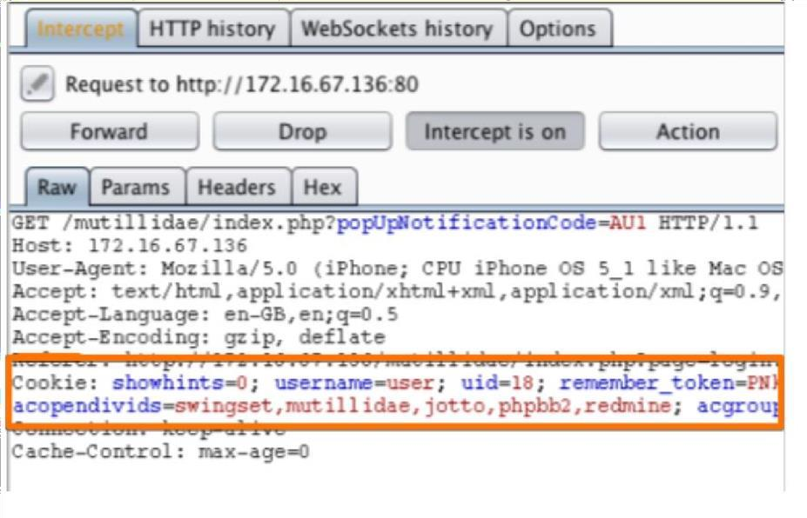

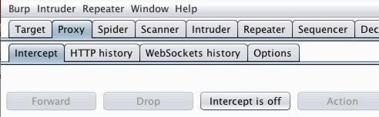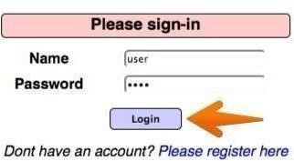

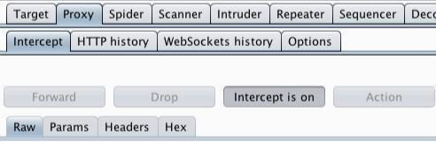

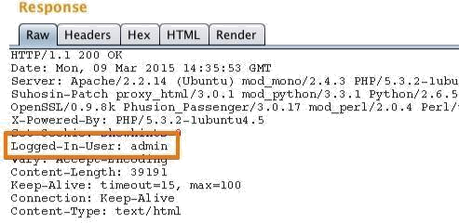

**Learning outcomes (What I have learnt):**

In the above experiment we have learnt that using session hijacking attack how the token session can be manipulated.